1. Why is vapour in the atmosphere considered as matter?

___________________________________________________________________________

1. Mention any one possible cause of dehydration in children.

___________________________________________________________________________

1. Of what importance are ventilators in a living house?

___________________________________________________________________________

1. Why do most cattle keepers prefer rearing Friesians to other types of dairy breeds of cattle?

___________________________________________________________________________

1. What happens to the pollen grains when they land on the stigma of a flower?

___________________________________________________________________________

1. Identify the type of tooth illustrated below

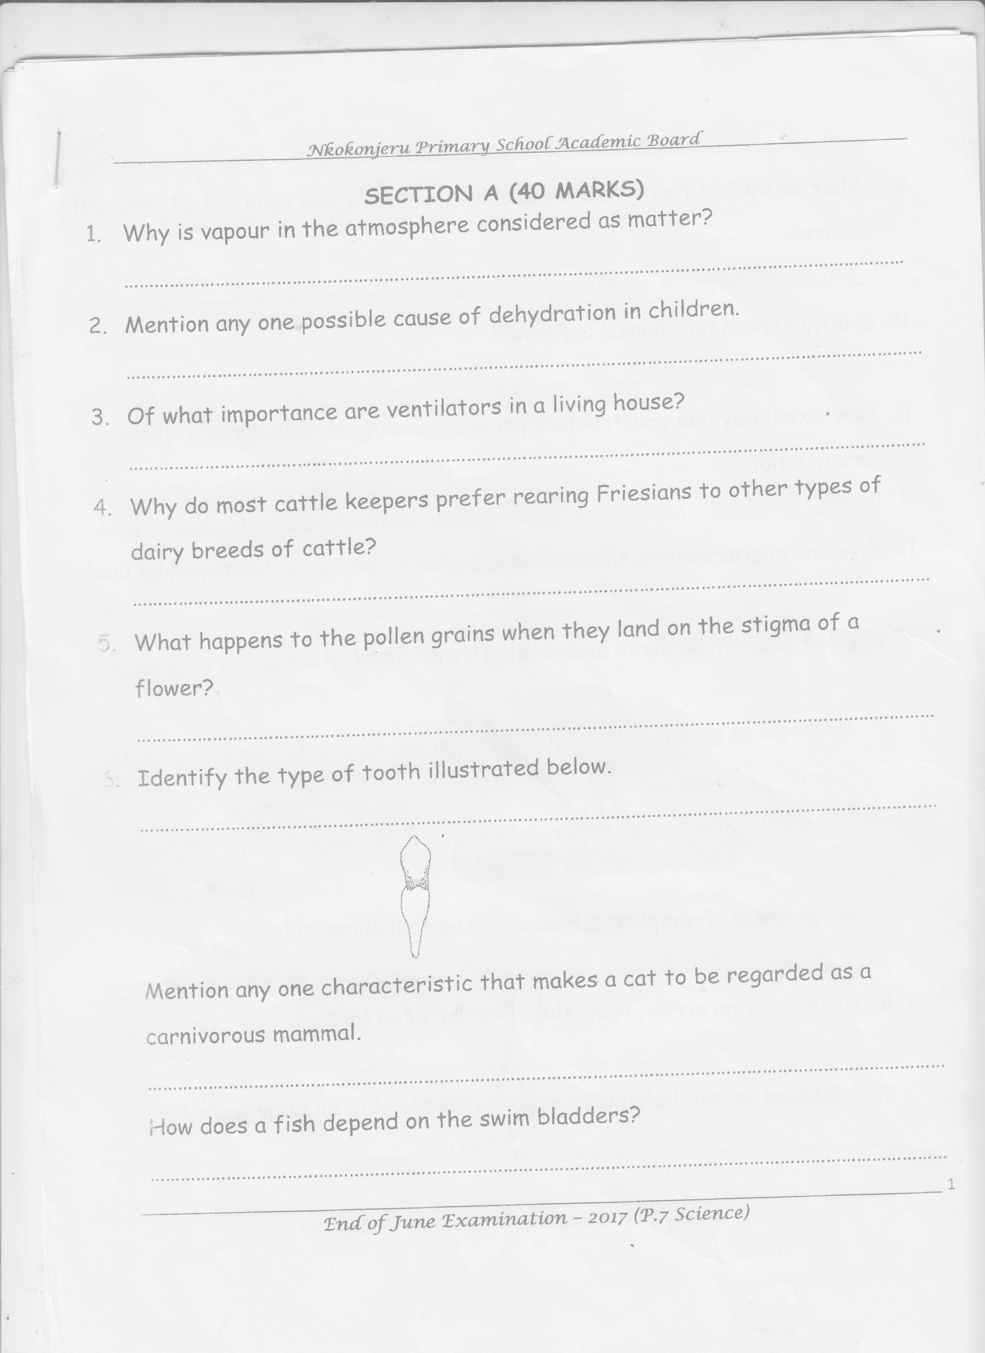

___________________________________________________________________________

1. Mention any one characteristic that makes a cat to be regarded as a carnivorous mammal.

___________________________________________________________________________

1. How does a fish depend on the swim bladders?

___________________________________________________________________________

1. What method of heat transfer enables water in a saucepan to boil when put on fire?

___________________________________________________________________________

1. Briefly explain how humus is formed.

___________________________________________________________________________

1. How do railway line constructors prevent bending of rails during railway construction?

___________________________________________________________________________

1. Give one characteristic that makes enzymes to be easily destroyed by heat.

___________________________________________________________________________

**Use the diagram below to answer questions 13 and 14.**

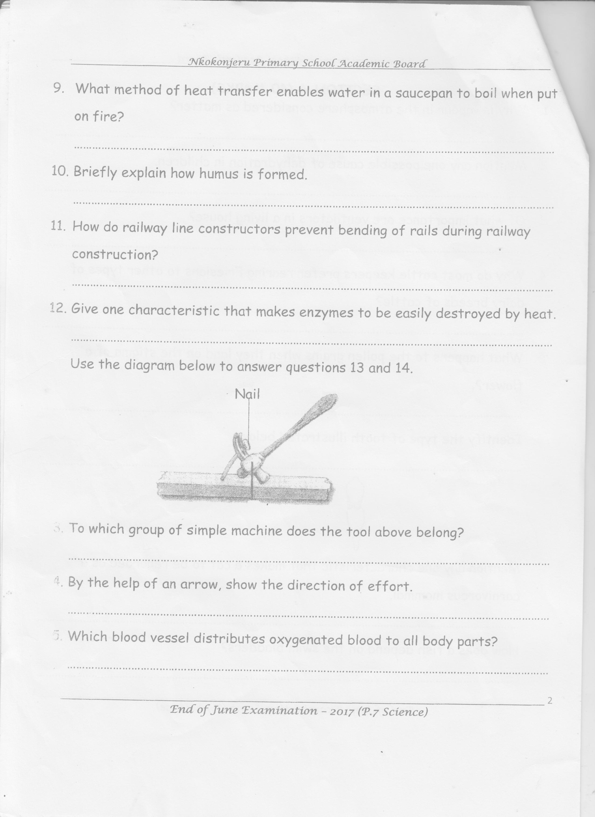

1. To which group of simple machine does the tool above belong?

___________________________________________________________________________

1. By the help of an arrow, show the direction of effort.
2. Which blood vessel distributes oxygenated blood to all body parts?

___________________________________________________________________________

1. Why do images in a pinhole camera appear upside down on the screen?

___________________________________________________________________________

1. Apart from excretion, write any other importance of sweating to the human body.

___________________________________________________________________________

1. How does smoking lead to lung cancer?

___________________________________________________________________________

1. Placenta plays an important role during the development of the baby in the womb. How useful is the placenta to the baby?

___________________________________________________________________________

1. Identify the effect of too much diarrhoe and vomiting to a person.

___________________________________________________________________________

1. Which kind of injury of the muscular and skeletal system is caused by over stretched muscles?

___________________________________________________________________________

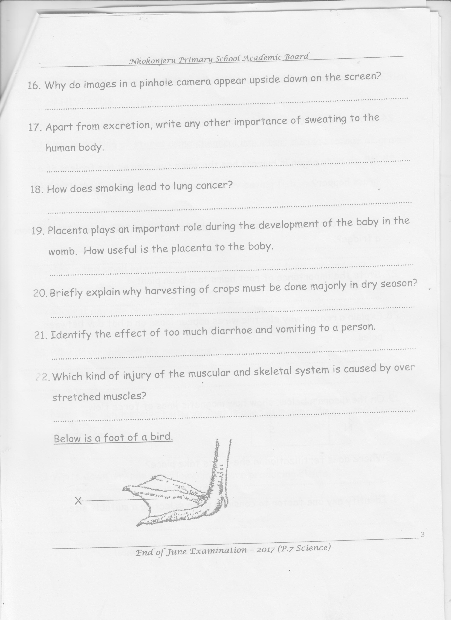**Below is a foot of a bird**

1. Which type of foot is shown above?

___________________________________________________________________________

1. To which group of birds does the above foot belong?

___________________________________________________________________________

1. State the usefulness of part X to birds with such a foot.

___________________________________________________________________________

1. Which body organ in humans has the same function as the feelers of a grass hopper?

___________________________________________________________________________

1. Why are drops of water seen around a bottle which has been removed from a fridge?

___________________________________________________________________________

1. State the importance of root hairs to a bean plant.

___________________________________________________________________________

1. Explain a reason why electric wires appear loose on a hot day between poles.

___________________________________________________________________________

1. On the diagram below, show how magnetic lines of force flow.

**N S**

1. Where does fertilization in she-goats take place?

___________________________________________________________________________

1. Identify any one factor to consider when selecting a suitable site.

___________________________________________________________________________

1. Identify any one urinary tract infections that can easily lead to contraction of HIV/ AIDS.

___________________________________________________________________________

1. How is dusting of stores using chemical important during storage of grains?

___________________________________________________________________________

1. State the food deficiency prevented by eating fish.

___________________________________________________________________________

1. Mention the type of manure got from rabbitary project.

___________________________________________________________________________

1. How is the small intestine adapted to its role of food absorption?

___________________________________________________________________________

1. Suggest any one characteristic of seeds dispersed by animals.

___________________________________________________________________________

1. Why do amphibians lay many eggs?

___________________________________________________________________________

1. Name the non-metallic material that is used in making the positive terminal of a dry cell.

___________________________________________________________________________

1. Write down any one non-flowering spore producing plants.

___________________________________________________________________________

**SECTION B**

1. a) How are monotremes different from other mammals?

___________________________________________________________________________

___________________________________________________________________________

b) What name is given to animals that are active at night and sleep during day?

___________________________________________________________________________

c) Give any two groups of vertebrates besides mammals.

i)___________________________________________________________________________

ii)___________________________________________________________________________

1. a) Name the static electricity in nature.

___________________________________________________________________________

b) What force helps the above type of electricity to take place?

___________________________________________________________________________

c) Give one way in which the electricity in (a) above is a disadvantage in the environment.

___________________________________________________________________________

d) How is the electricity above helpful to a crop farmer?

___________________________________________________________________________

1. **Study the diagram below and answer questions that follow**

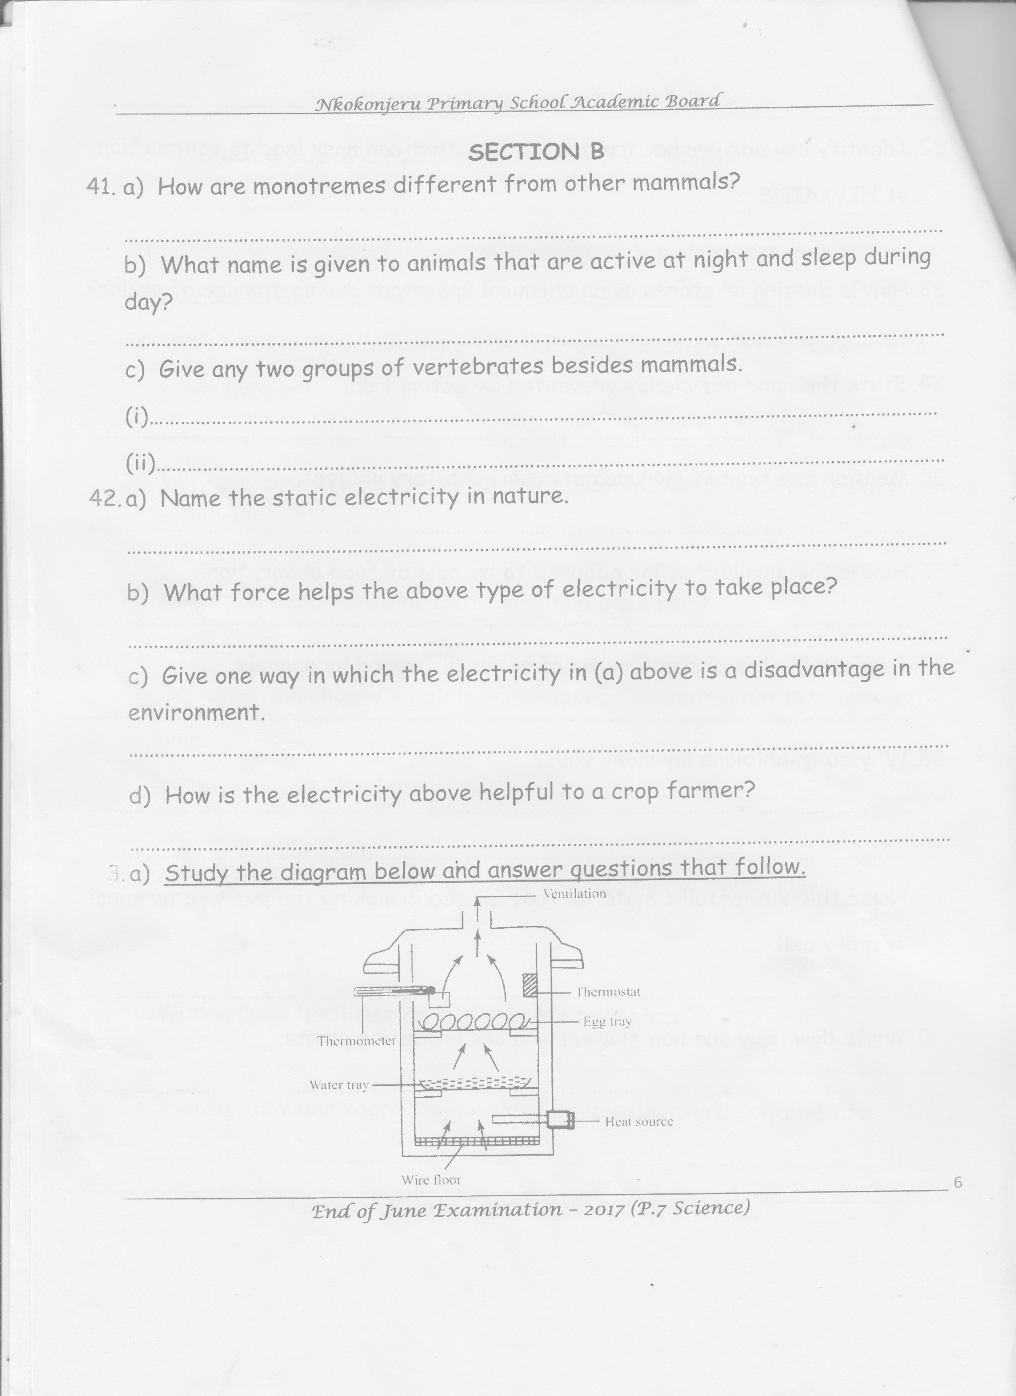

1. Name the machine show above. _______________________________________________
2. What method of hatching eggs use the machine above?

__________________________________________________________________________

1. Give one advantage of using the above machine in hatching of eggs.

__________________________________________________________________________

1. Give a reason why the machine above is not commonly used in rural areas.

__________________________________________________________________________

1. a) How is a charcoal obtained?

___________________________________________________________________________

b) During the processing of charcoal, state the reason why each of the following is carried out;

i) covering the wood with grass.

___________________________________________________________________________

ii) covering the wood and grass with soft/ moist soil.

___________________________________________________________________________

c) Mention one material recommended for stopping charcoal from burning during it’s harvest.

___________________________________________________________________________

1. a) What are resources?

___________________________________________________________________________

___________________________________________________________________________

b) Identify any two energy resource found in our environment.

i)___________________________________________________________________________

ii)___________________________________________________________________________

c) Why should non-renewable resources be used sparingly?

___________________________________________________________________________

1. 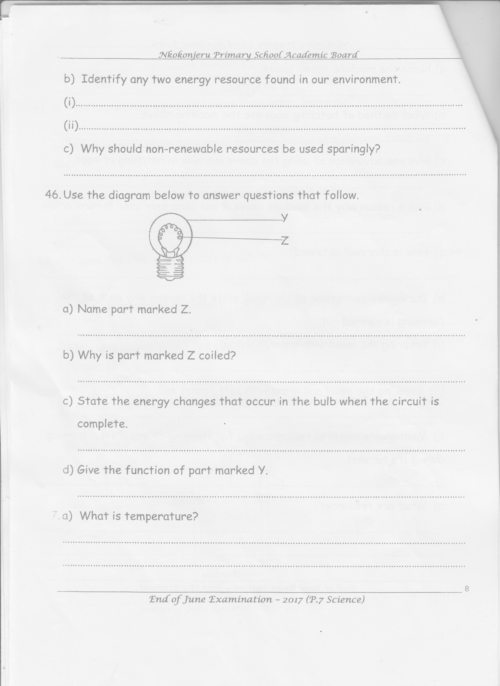**Use the diagram below to answer questions that follow**
2. Name part marked Z.____________________________________________________
3. Why is part marked z coiled?

__________________________________________________________________________

1. State the energy changes that occur in the bulb when the circuit is complete.

__________________________________________________________________________

1. Give the function of part marked Y.

__________________________________________________________________________

1. a) What is temperature?

___________________________________________________________________________

___________________________________________________________________________

b) How does increase in temperature affect plants?

___________________________________________________________________________

c) Give one reason why mercury is used in thermometers.

___________________________________________________________________________

d) Convert 770F to Celsius scale.

___________________________________________________________________________

1. 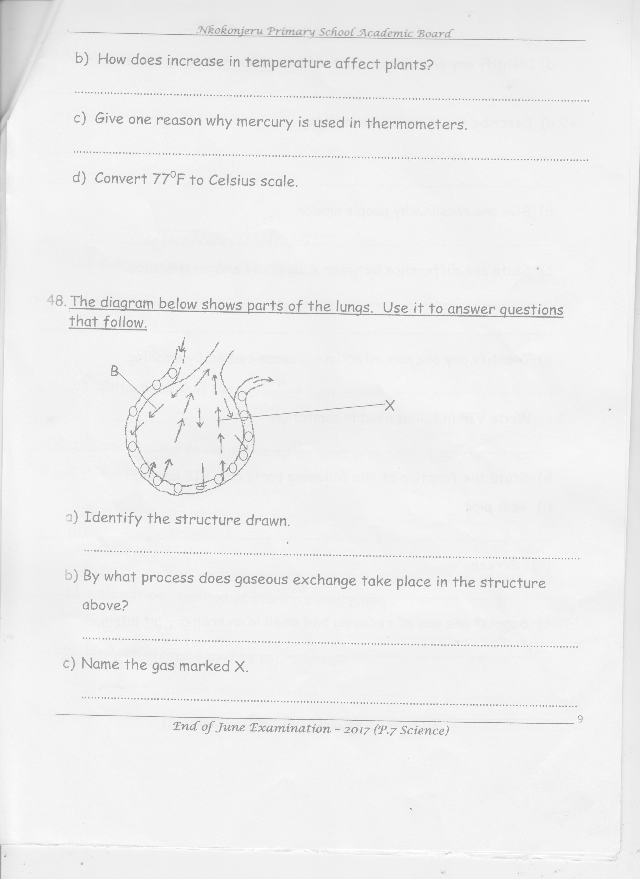**The diagram below shows parts of the lungs. Use it to answer questions that follow.**
2. Identify the structure drawn.

__________________________________________________________________________

1. By what process does gaseous exchange take place in the structure above?

__________________________________________________________________________

1. Name the gas marked X. ______________________________________________________
2. Identify any one disease that attacks the respiratory system.

__________________________________________________________________________

1. a) Describe the term active smoking.

___________________________________________________________________________

___________________________________________________________________________

b) Give one reason why people smoke.

___________________________________________________________________________

c) State one difference between drug abuse and drug misuse.

___________________________________________________________________________

___________________________________________________________________________

d) Identify any one non-infectious disease caused by smoking.

___________________________________________________________________________

1. a) Write VIP in full as used in sanitation.

___________________________________________________________________________

b) State the function of the following parts on a VIP latrine;

i) Vent pipe

___________________________________________________________________________

ii) Screen

___________________________________________________________________________

c) Suggest one way of reducing bad smell in an ordinary pit latrine.

___________________________________________________________________________

1. 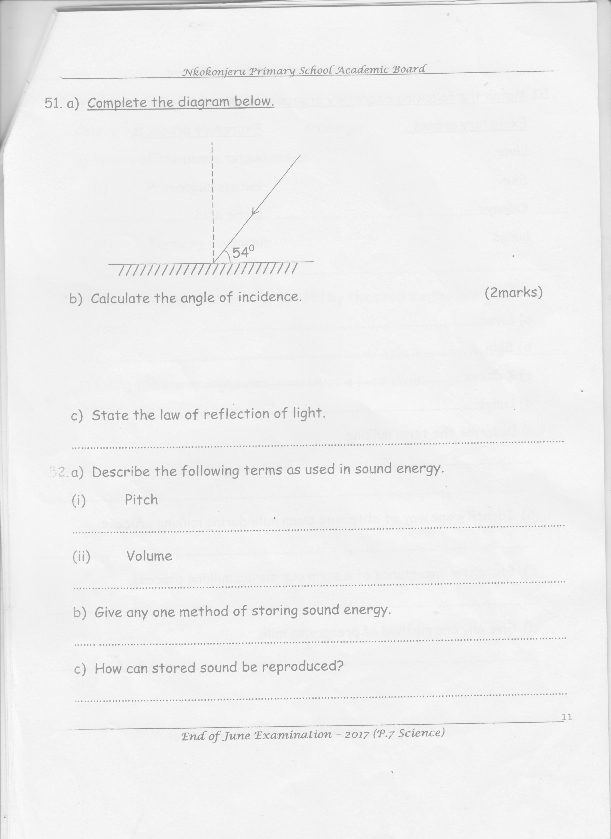a) Complete the diagram below

b) Calculate the angle of incidence (2marks)

c) State the law of reflection of light.

___________________________________________________________________________

1. a) Describe the following terms as used in sound energy.
2. Pitch

___________________________________________________________________________

1. Volume

___________________________________________________________________________

b) Give any one method of storing sound energy

___________________________________________________________________________

c) How can stored sound be reproduced?

___________________________________________________________________________

1. **Match the following excretory organs with their excretory products**

**Excretory organs Excretory products**

Liver water vapour

Skin excess sugar

Kidneys lactic acid

Lungs urine

1. Liver ______________________________________________________________
2. Skin ______________________________________________________________
3. Kidneys ______________________________________________________________
4. Lungs ______________________________________________________________
5. a) Describe the term milking.

___________________________________________________________________________

b) Identify one way of obtaining clean milk during milking process.

___________________________________________________________________________

c) State the importance of a strip cup during milking process

___________________________________________________________________________

d) Give any one method of preserving milk.

___________________________________________________________________________

1. **Study the list or organisms below;**

caterpillar , hen , cabbage, eagle

1. Which of the above organism is;
2. primary consumer ____________________________________________________
3. tertiary consumer ____________________________________________________
4. Name the source of energy needed by the producer to make its own food.

__________________________________________________________________________

1. Using the above organisms, construct a food chain.

**End.**